**Personal Portfolio**

Zubair Siregar (n9142614)

**Artefact 1.**

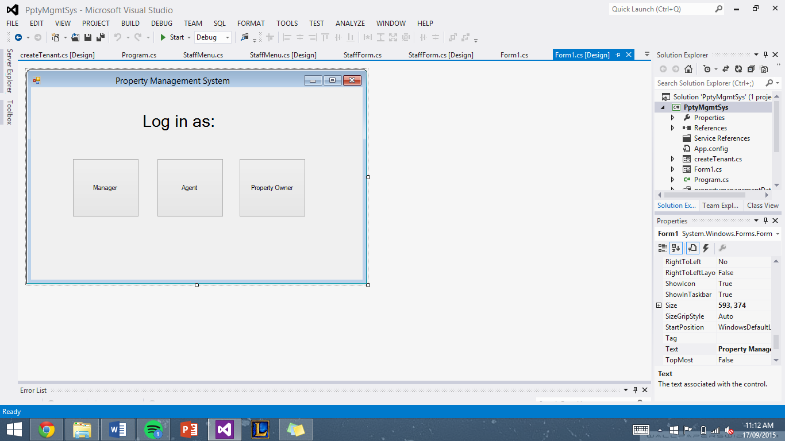

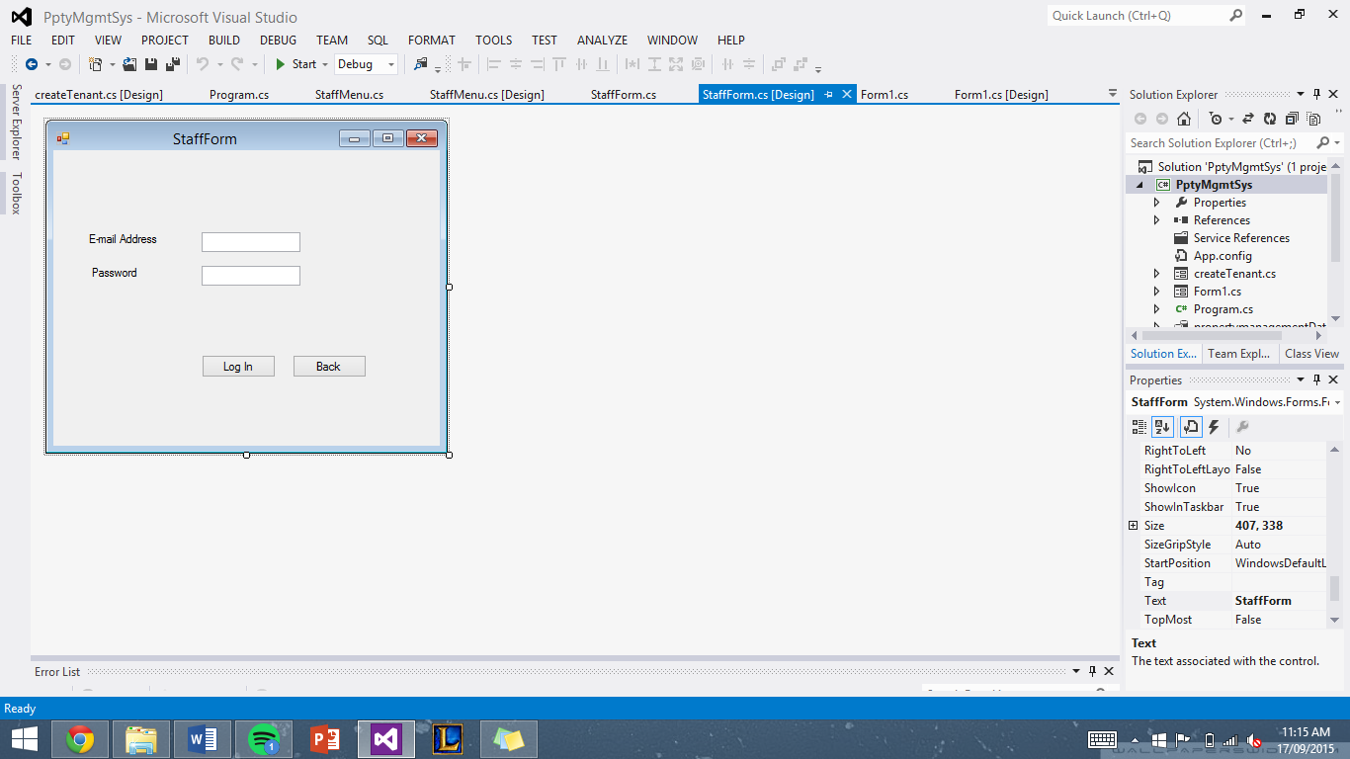

As I am working on the back end system of the property management system, most of my workload revolves around designing, coding and linking to MySQL database online. This is done using C# in visual studio. The first screenshot is a login option depending on the user’s role (owner/boss/staff). Users will then be linked to the second screenshot which is the login form. Users have to enter their e-mail address and also password which is then verified using the online database linked to the application. Minimal validation has been implemented like fill in all fields before logging in.

Artefact 2.

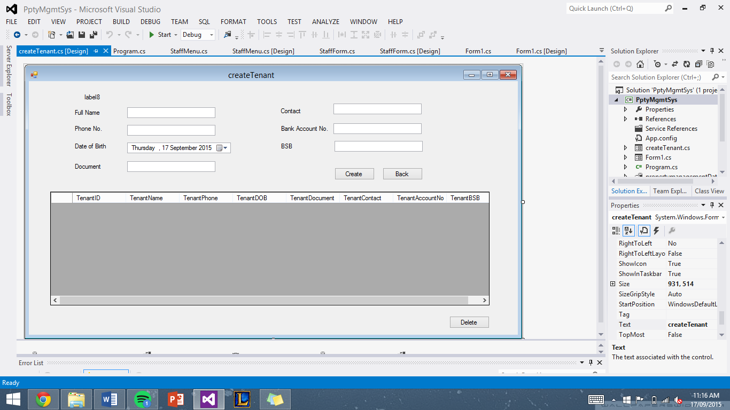

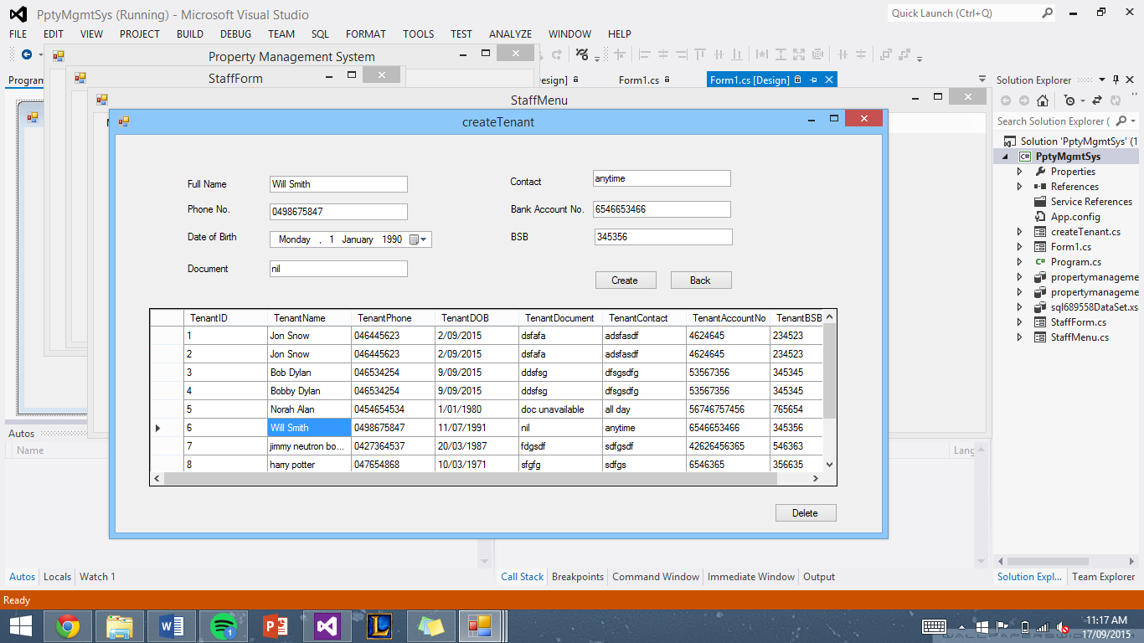

The second artefact shows one of the functions of what a staff or agent can do. This is the form where the staff can create a new record of a tenant and at the same time, view the complete list of all existing tenants in the ‘data grid view’. Also staffs are able to delete a record by selecting one of the rows and hitting the ‘delete’ button. One of the challenges of the whole process is manipulating inputs in text field appropriately and also passing correct queries to the online database.

Artefact 3.

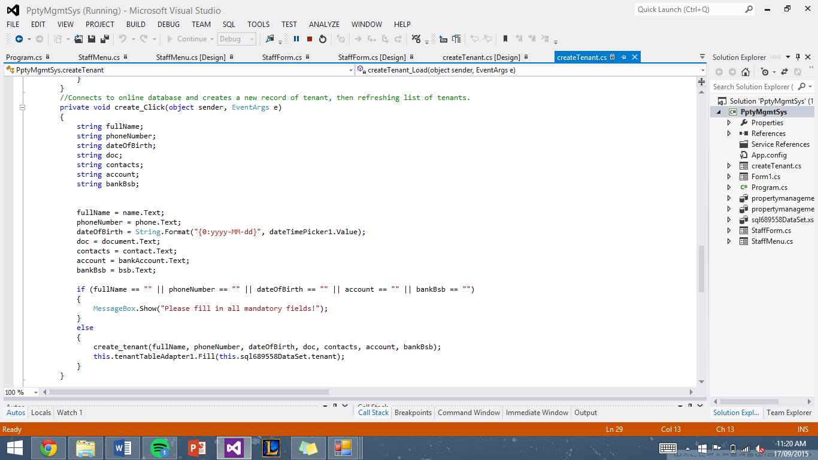

The screenshot above is the codes involved in manipulating the data in the text fields appropriately. Also shows a simple validation of text fields. Using the variables in the code, they’re passed to the ‘create_tenant’.

Artefact 4.

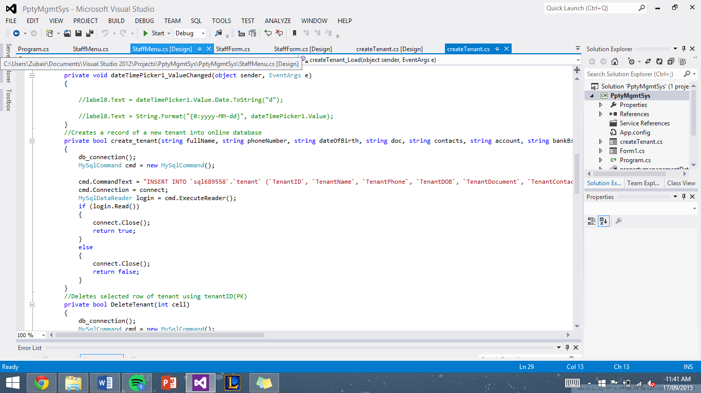

These are the codes involved in connecting to the online database and also passing through the correct query in the correct format. This process involved a lot of trial and errors, which eventually worked properly.

Artefact 5.

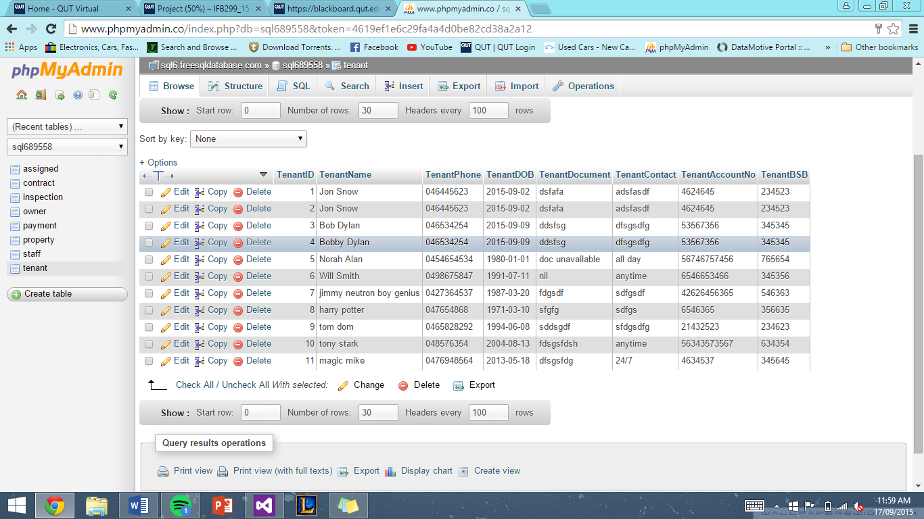

This is a screenshot of the online database which feeds data to the visual studio application. My other group mate, Alex, created the whole database on a website called freesqldatabase. However there were some fixes and components that needed adjusting like assigning primary key and also adding sample data.